1. Create and Add an IoT Device

2.2 Add a New Rule Chain

1. We will create a rule chain first. This will be used in the new device. Click on the Rule Chains button from the left panel. Then click the + button at the upper-right corner and select the Create new rule chain option.
2. In the pop-up window, type temperatureRule. Then, click Add to confirm.

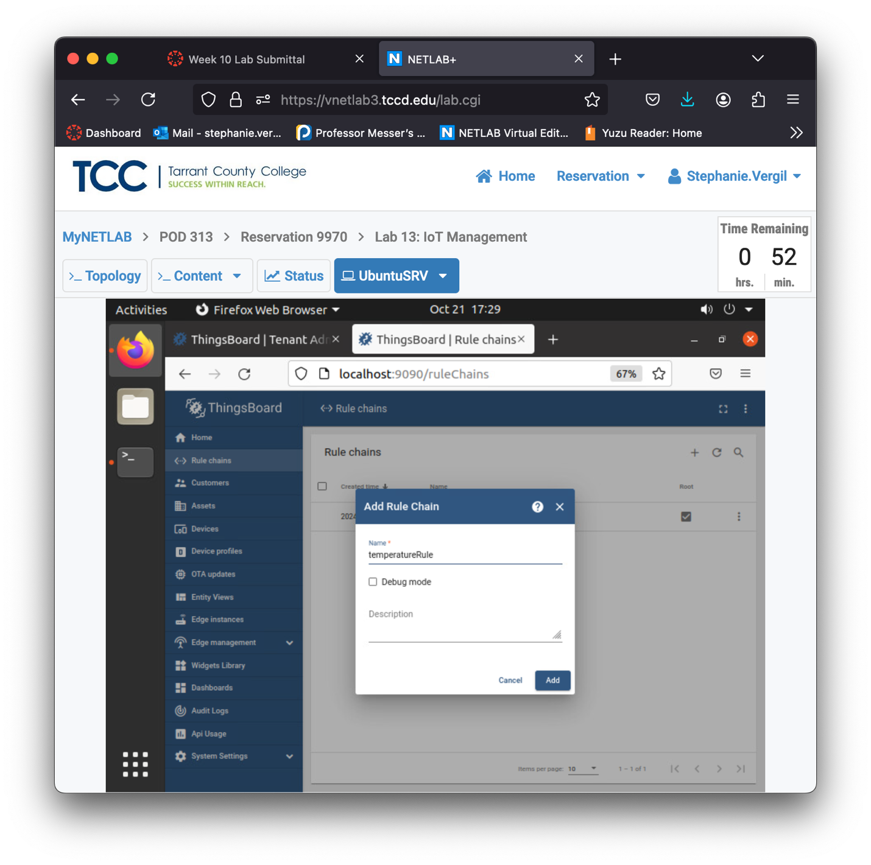

1. You will have two rule chains; click the Open rule chain button on the right side of the temperatureRule.
2. You will see something like this:

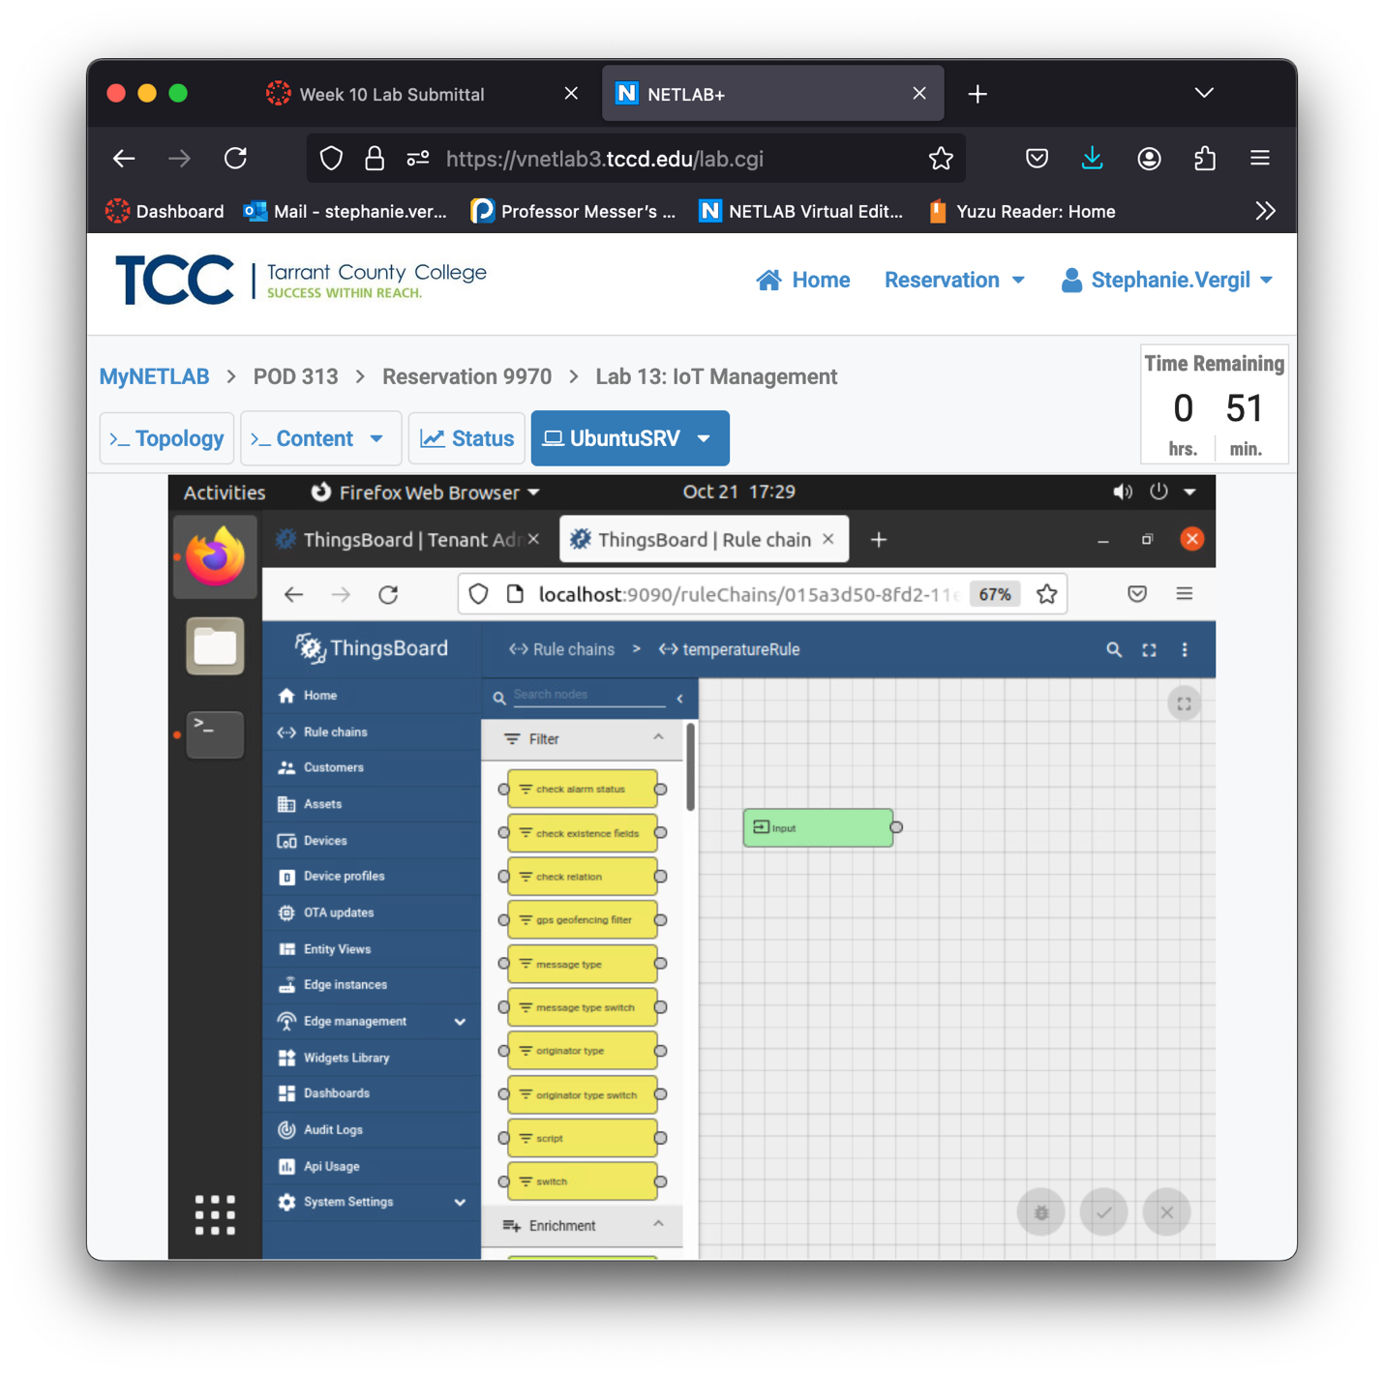

1. To the left side, find message type switch, click and drag it to the grids on the right. When prompted, type check POST telemetry as the Name. Then, click Add.
2. You should have something like this now:

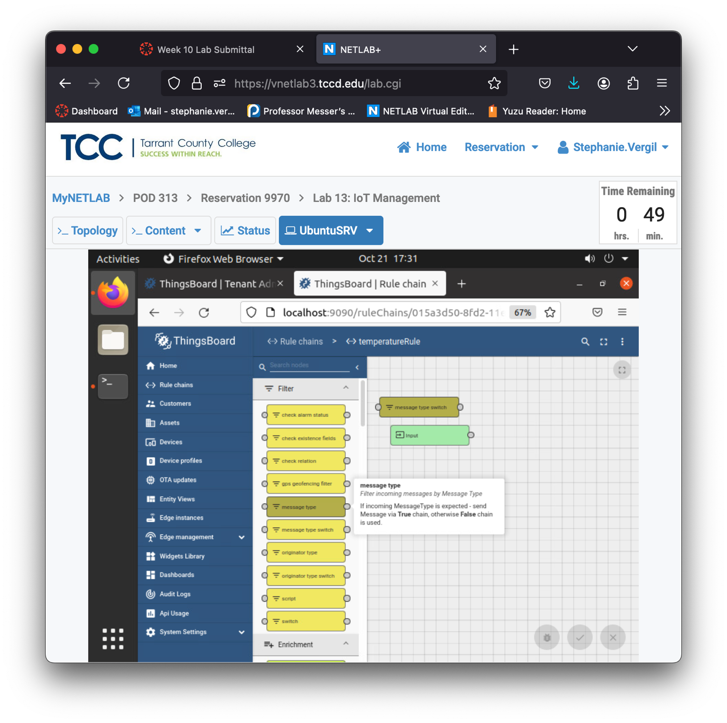

1. Next, find check existence fields and drag it to the grids.

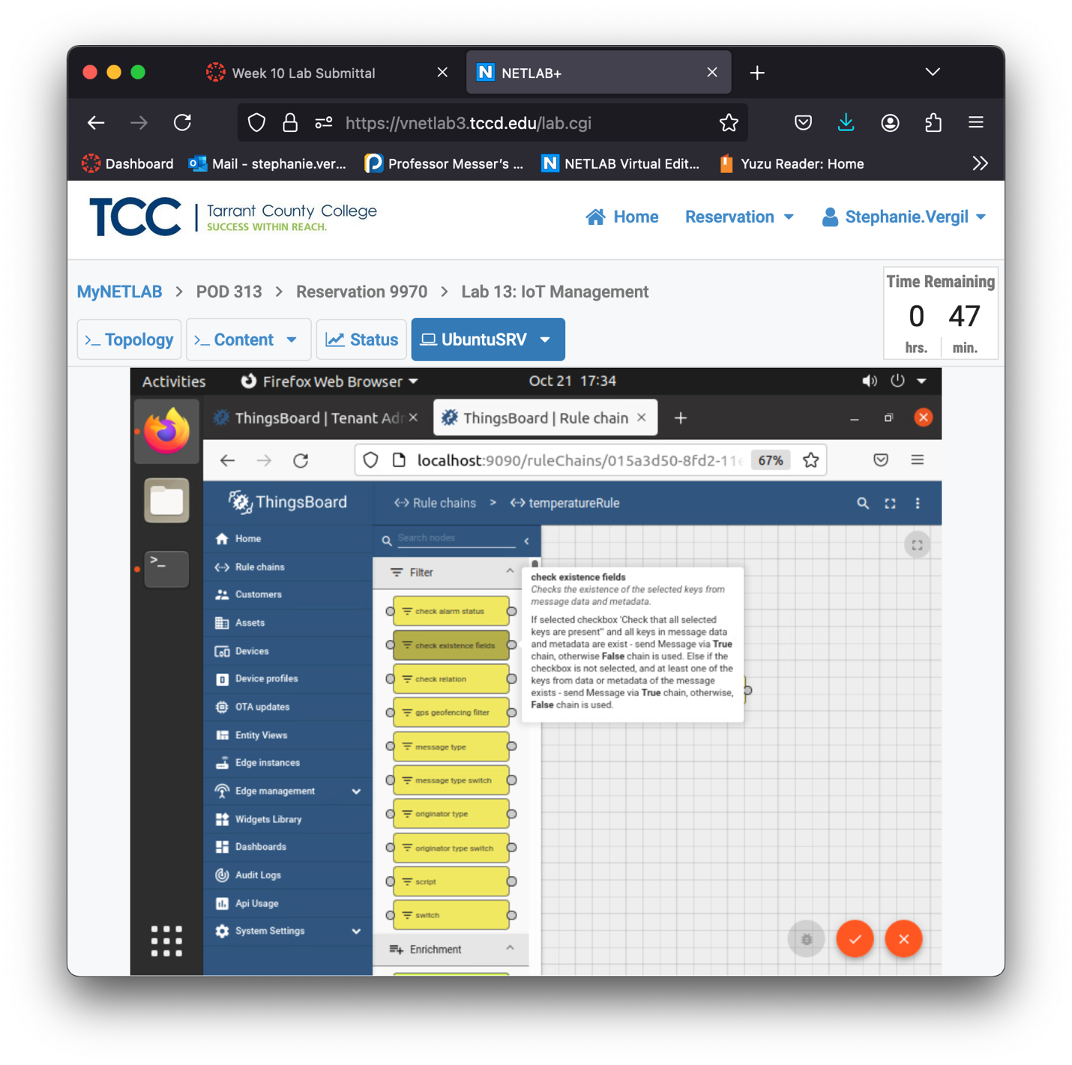

1. When prompted, type check temperature and humidity fields as the Name. In the Message data area, type temperature and press Enter; type humidity and press Enter. You should have something like what is shown below. Leave the Message metadata empty and click Add to confirm.

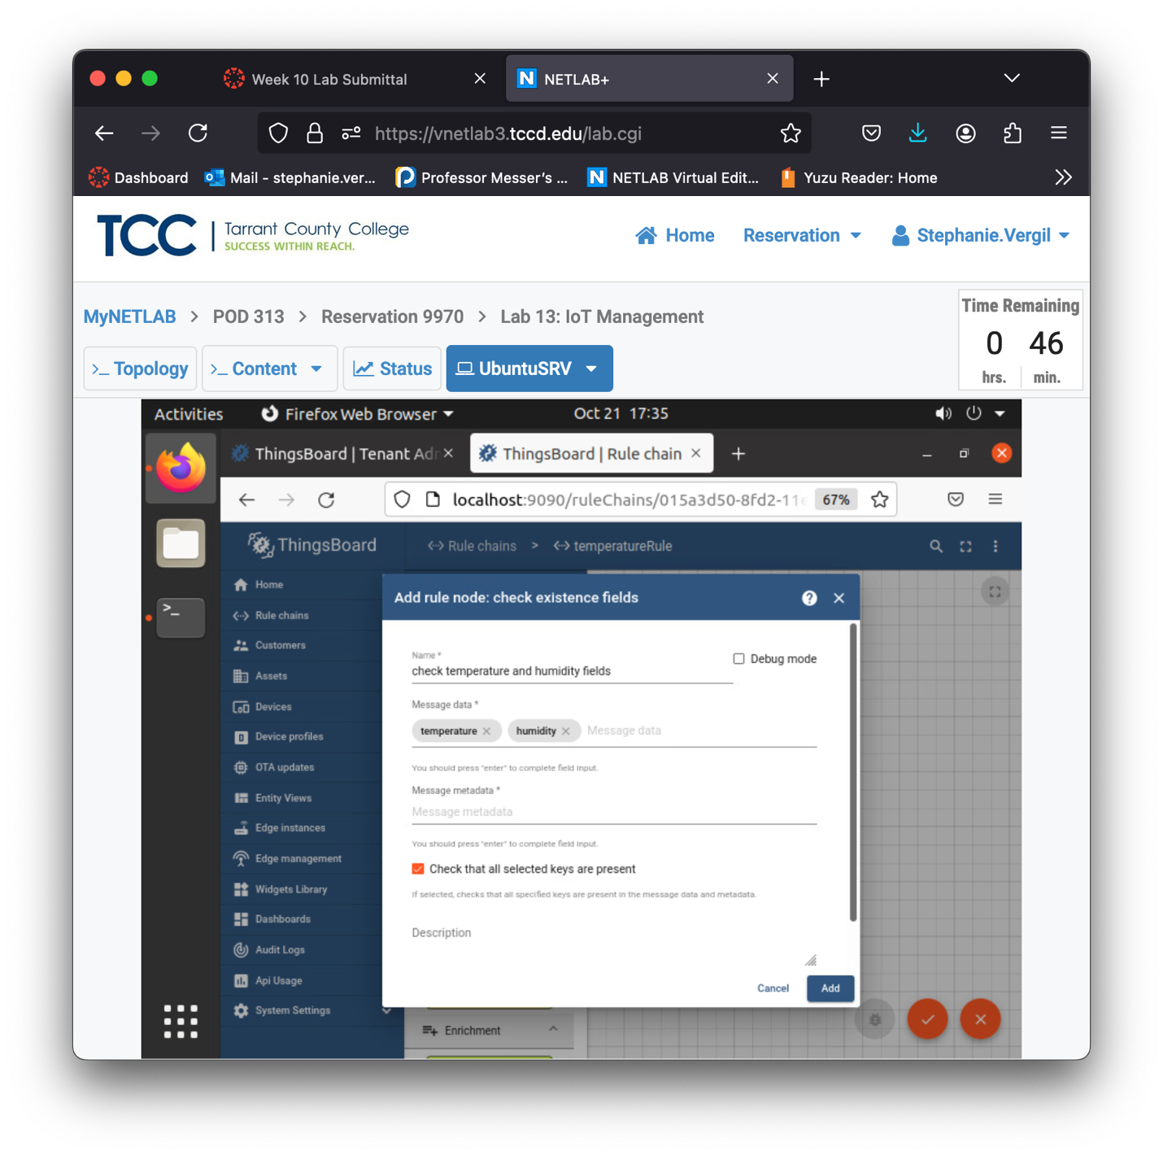

1. Next, find script and drag it to the grids.

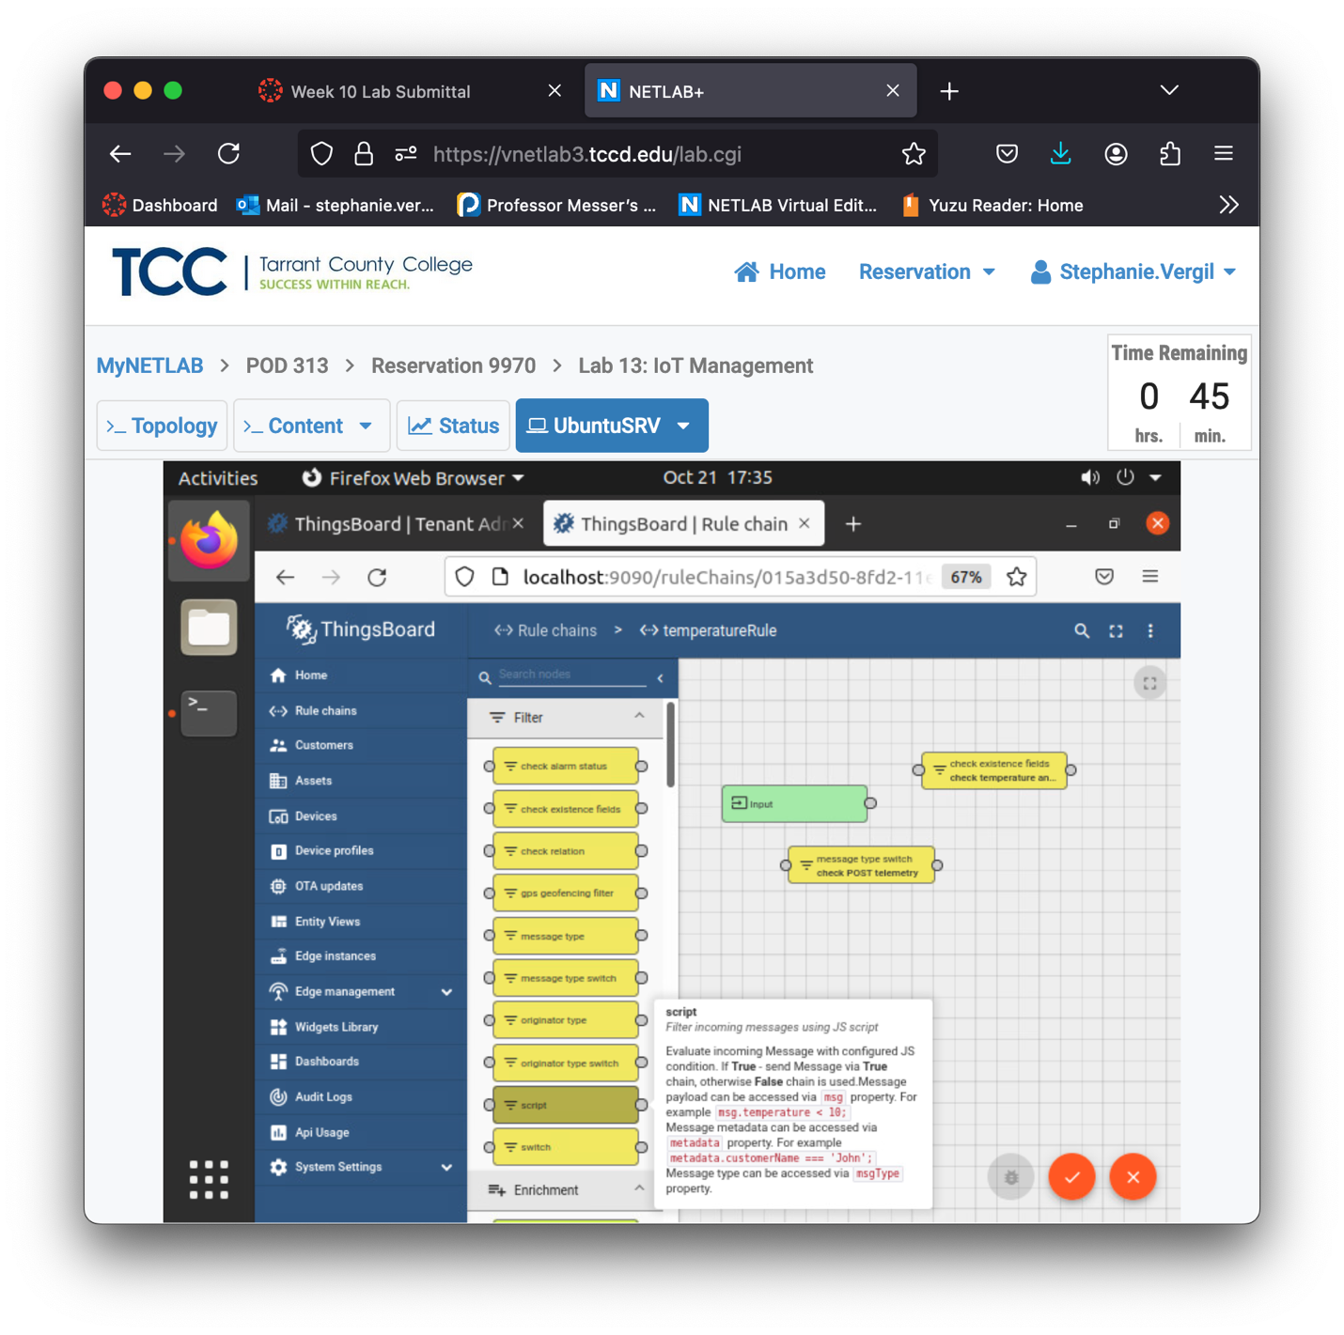

1. When prompted, type check temperature and humidity data as the Name, then change the script in the function Filter area. When finished, click Add to confirm.

The script should be:

return msg.temperature > 68 && msg.temperature < 71 && msg.humidity > 40 && msg.humidity < 60

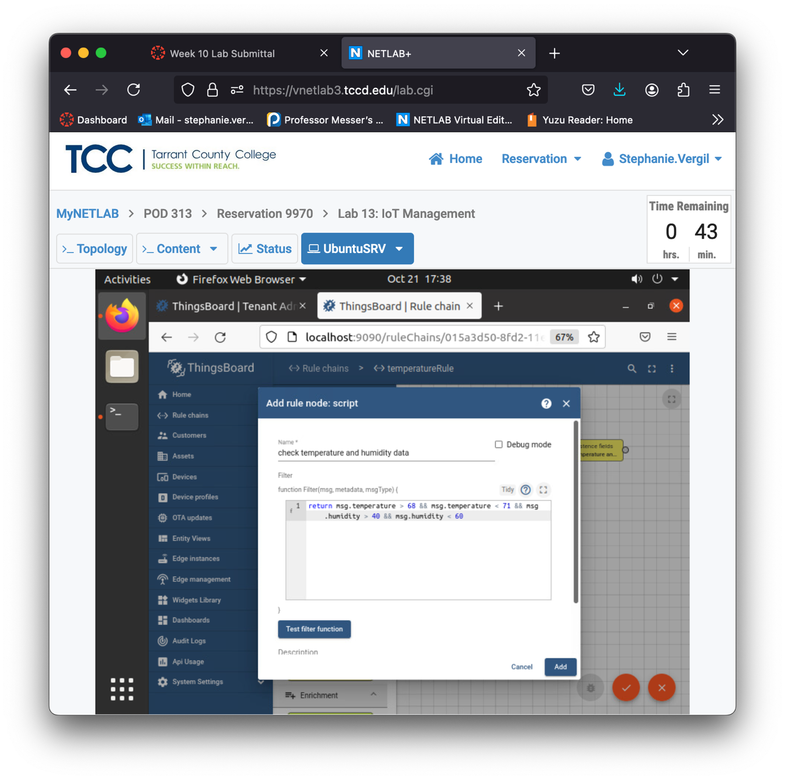

1. Once again, on the left side, find save timeseries and drag it to the grids. When prompted, type save the entry as the Name. Change the Default TTL in seconds to 3 and click Add to confirm.

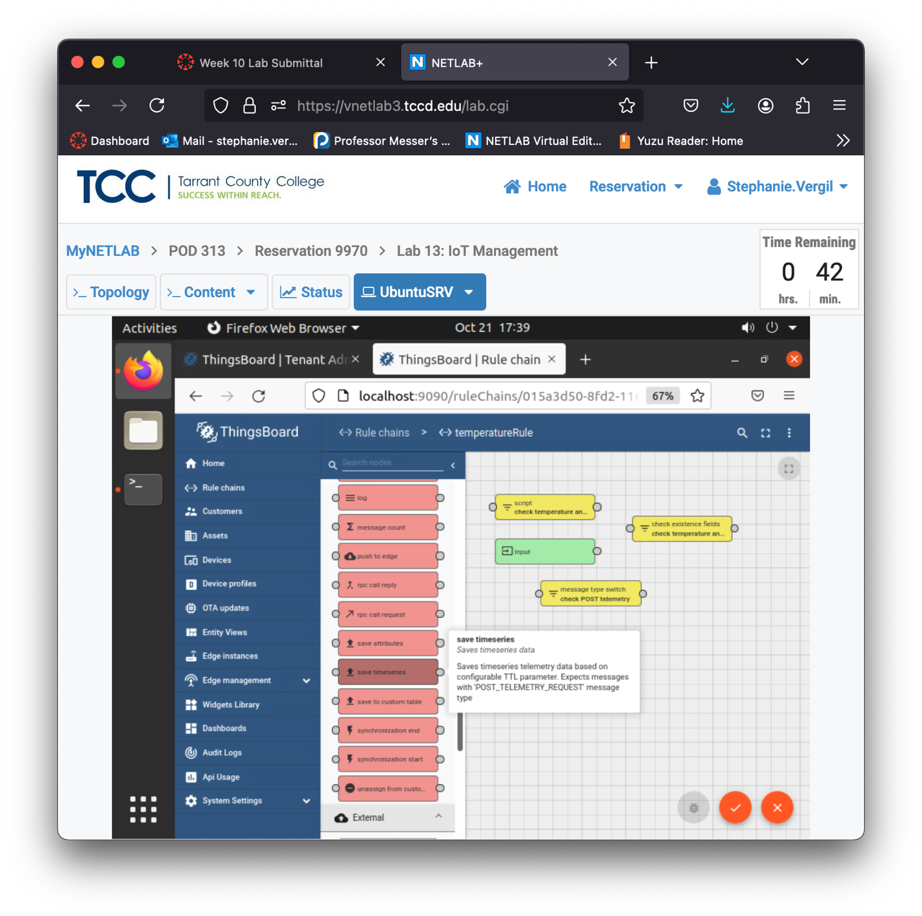

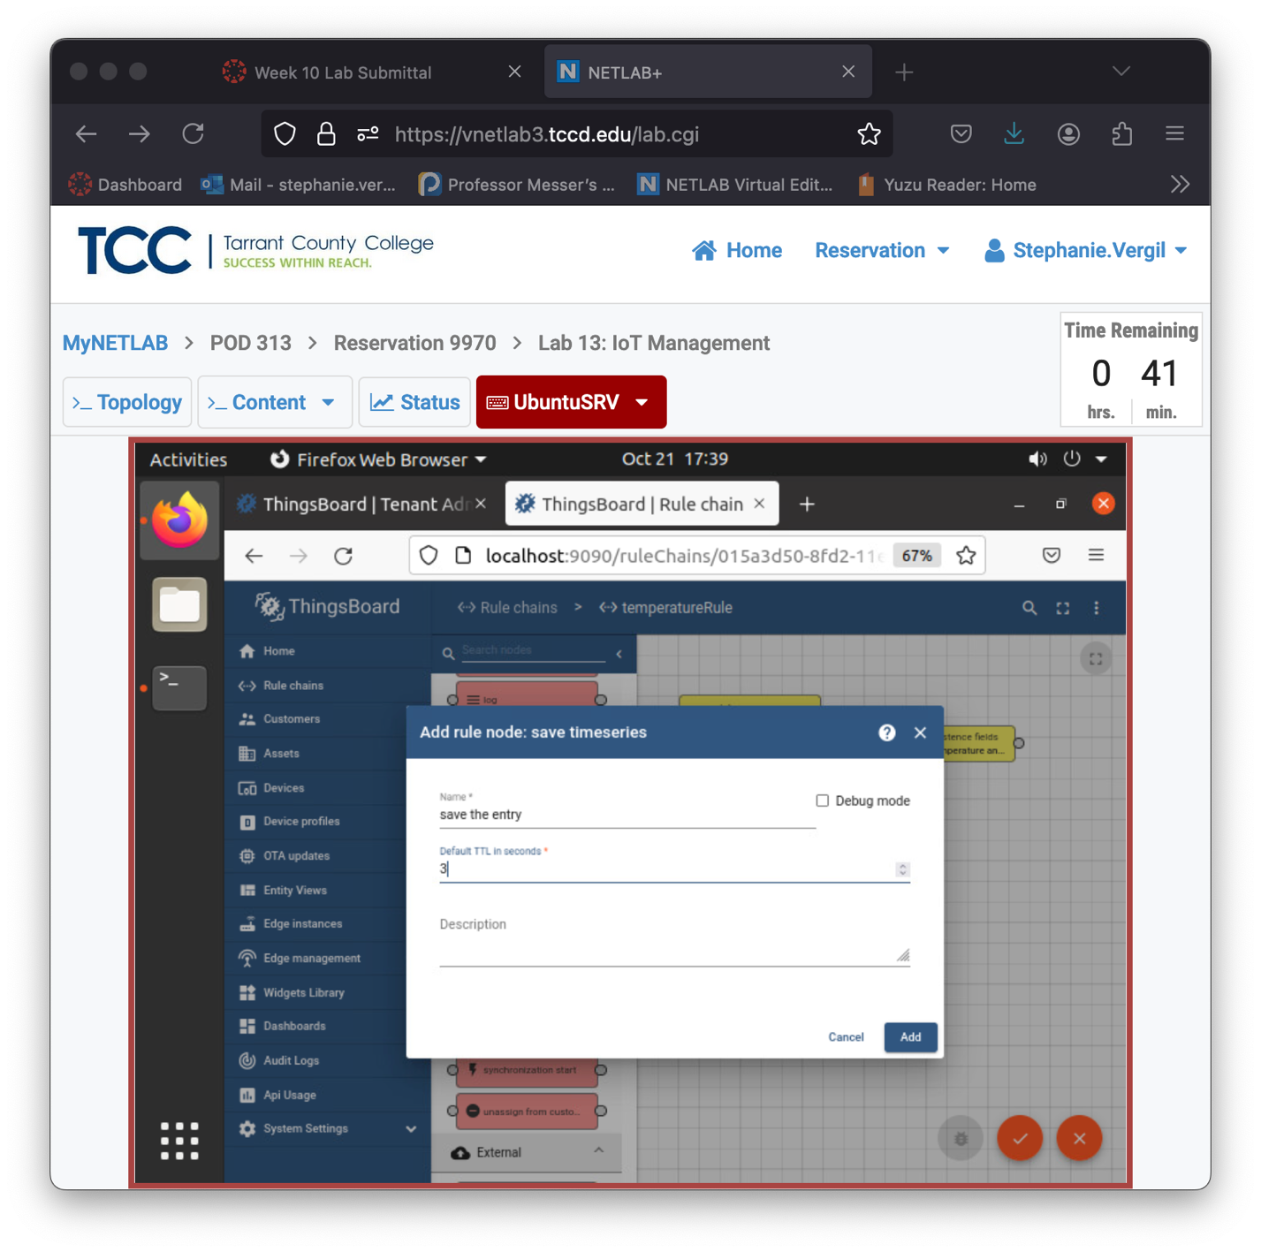

1. For the last time, on the left side, find create alarm and drag it to the grids.

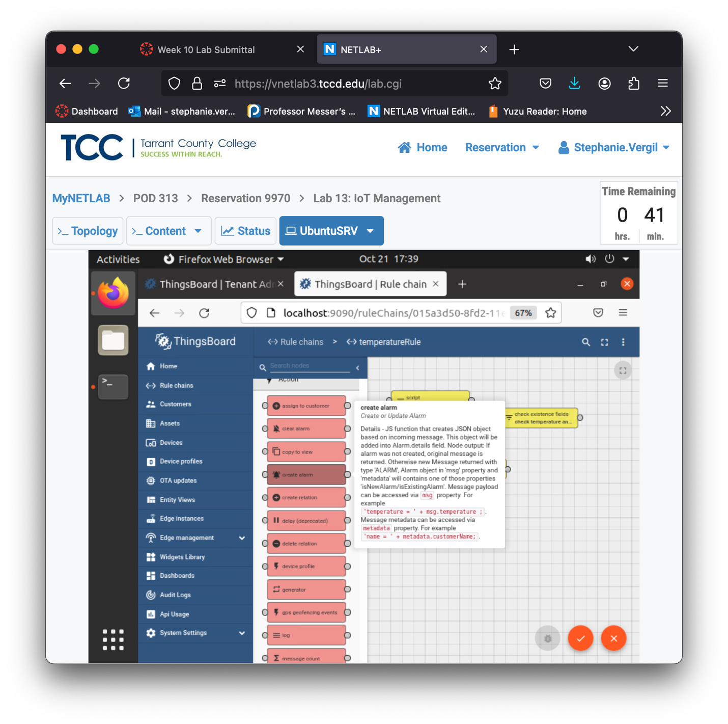

1. When prompted, type warning as the Name. Then, add the following script to the function Details area. When finished, click Add to confirm.

details.temperature = msg.temperature;

details.humidity = msg.humidity;

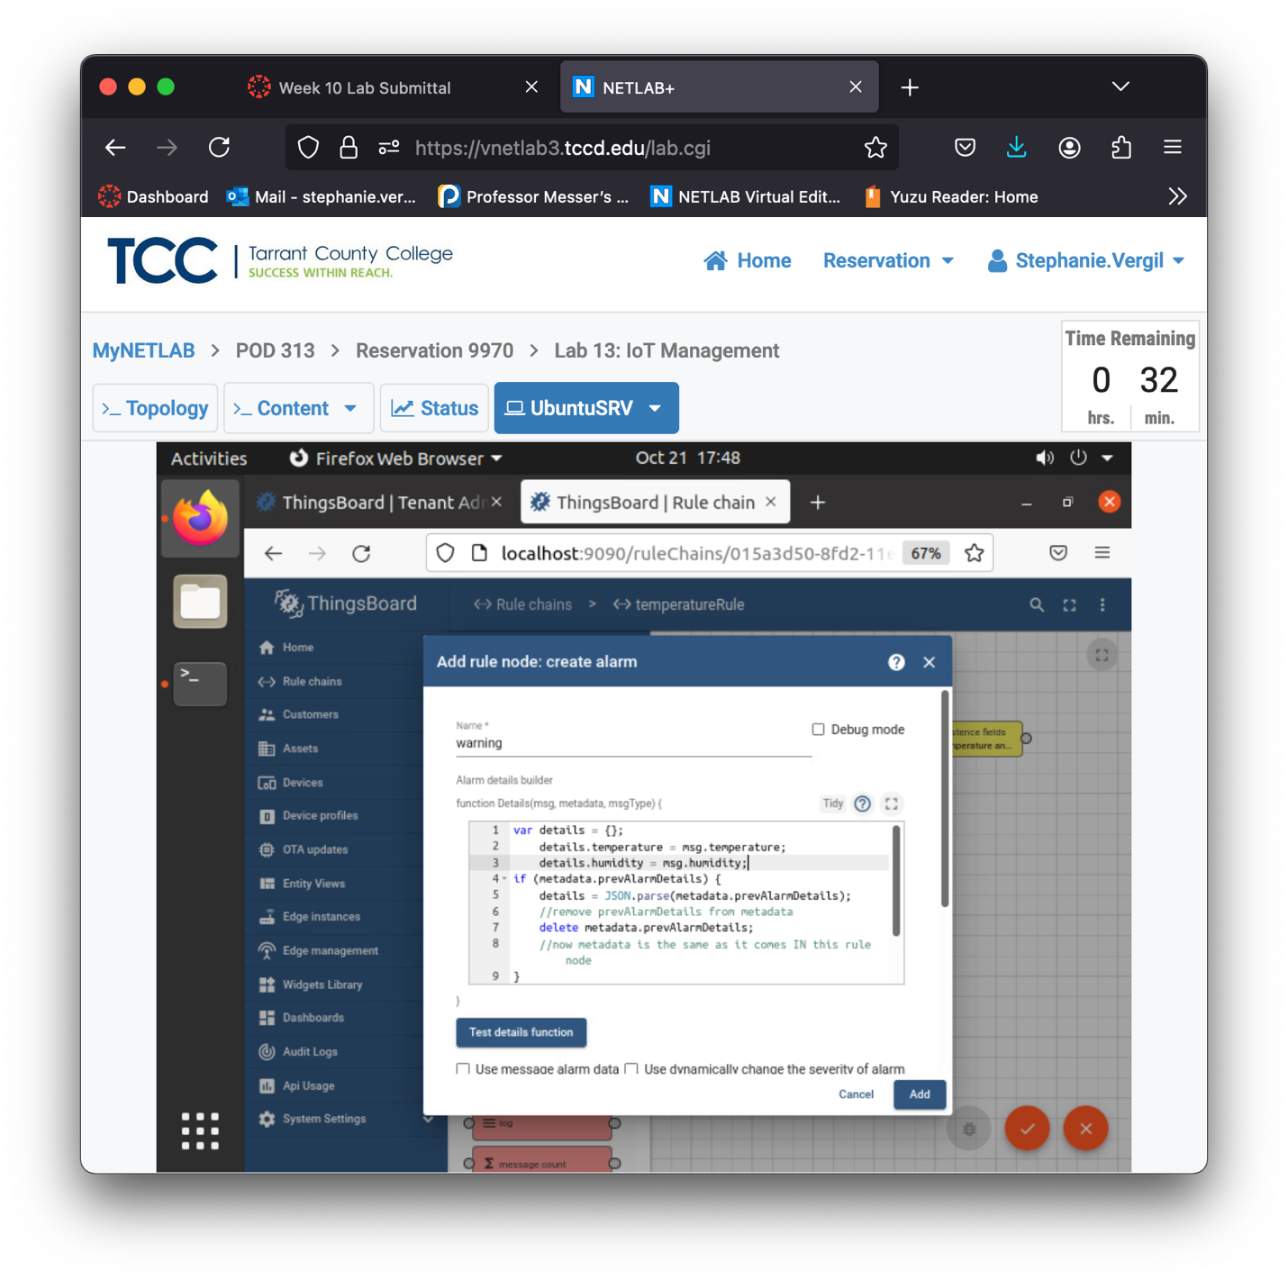

1. Your grid area should look something like this. The next step is to connect them to make a chain.

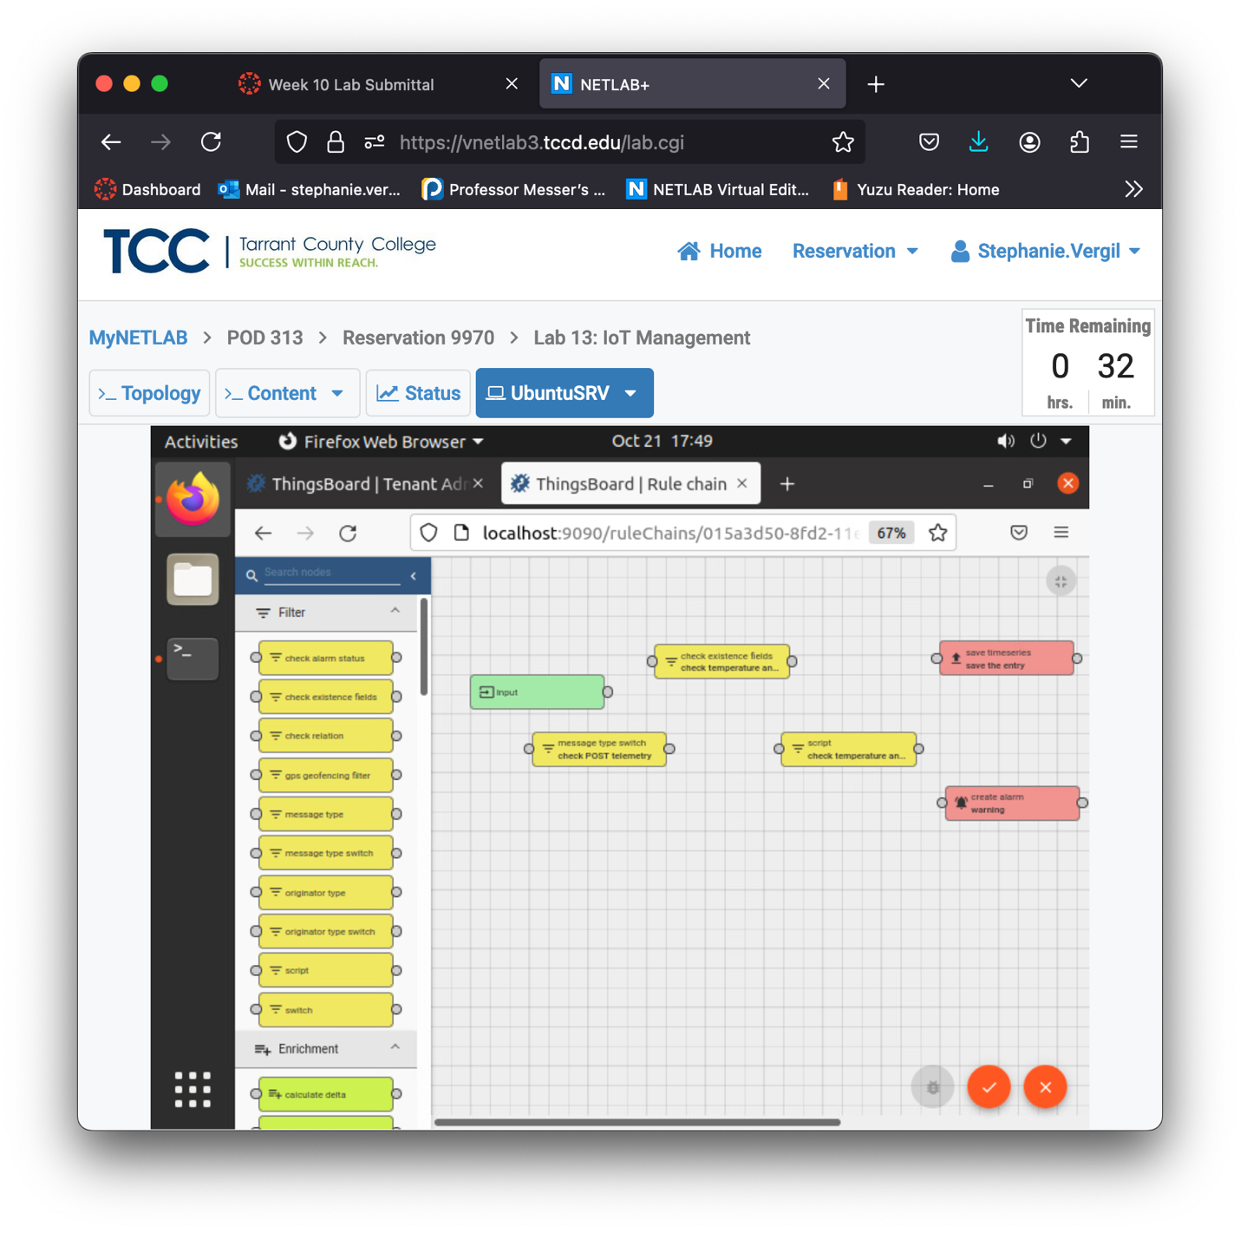

1. Click on the round connection point to the right side of Input. Click and drag it to the connection point on the left side of the message type switch. After you release the mouse, it should create a link with the arrow pointing to the direction of the data flow.
2. Use the same method to create a link between message type switch and check existence fields. When prompted, select Post telemetry as the Link label.

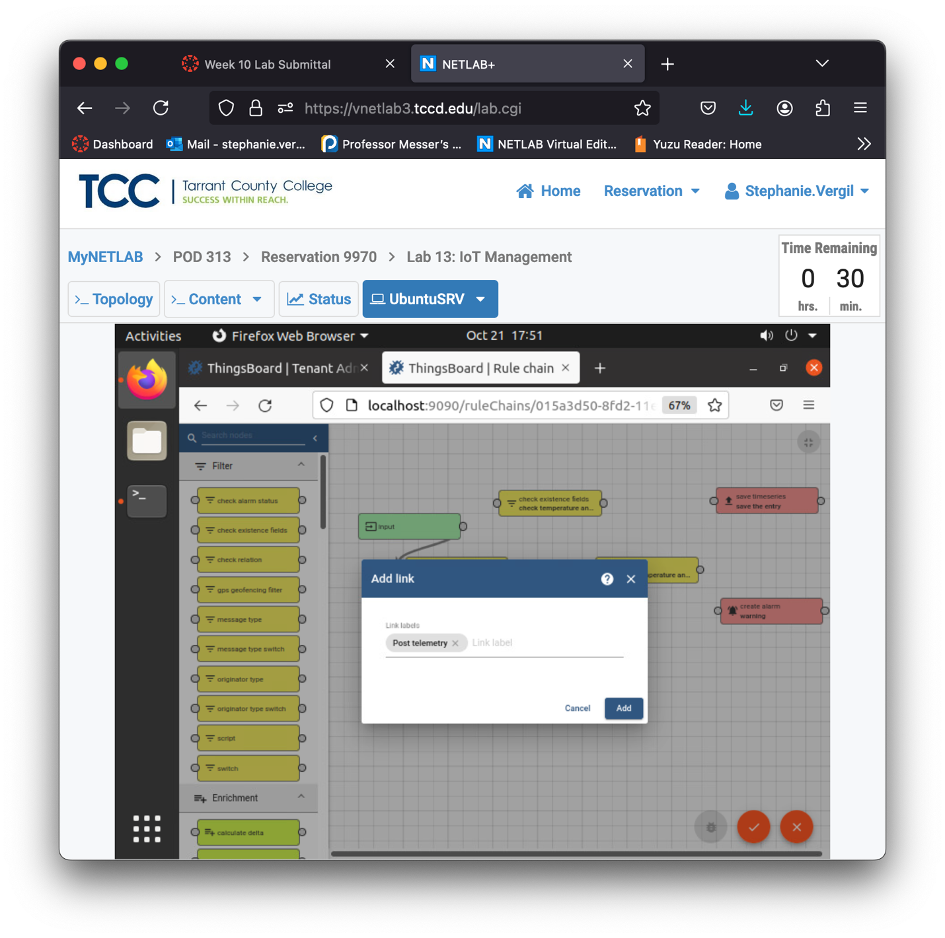

1. Then, add a link between check existence fields and script. When prompted, select True as the Link label. Click Add to confirm.
2. Add a link from script to save timeseries. When prompted, select True. Click Add to confirm.
3. Add a link from script to create alarm. When prompted, select False. Click Add to confirm.
4. With all links added, everything should look like this:

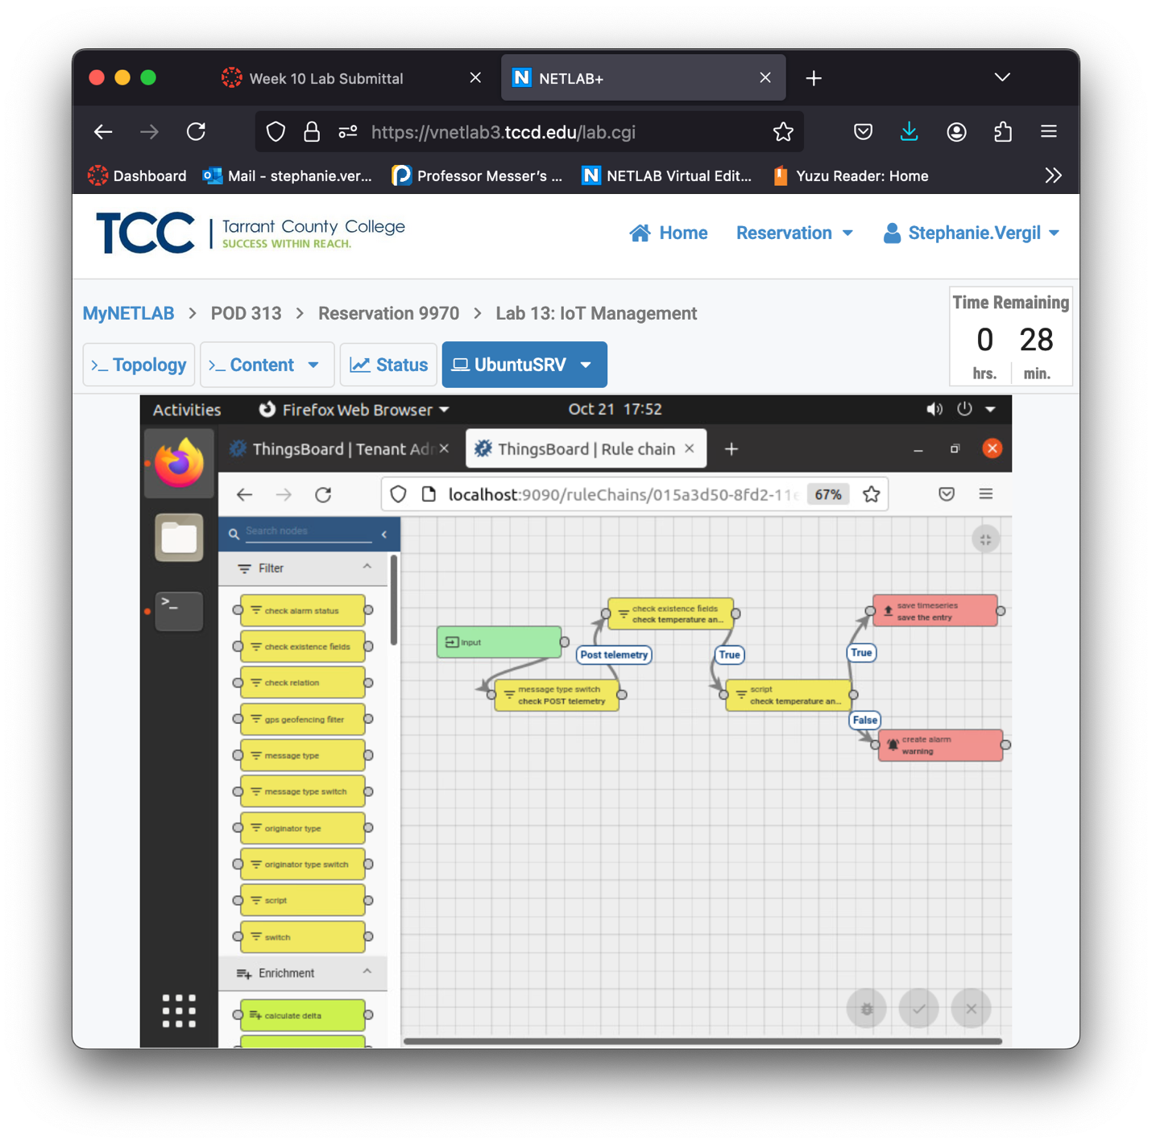

1. Save the changes by clicking the orange checkmark button at the lower-right corner.
2. Leave the window open and proceed to the next step.
   1. Add New Device
3. Click on Devices on the left side. Then, click the + button in the upper-right corner and select the Add new device option.
4. The Add new device window will appear. Type temperatureSensor as the Name. Then, select to check Create new device profile. Type mqtt as the Device profile name. Select temperatureRule for the Rule chain option, and Main for the Queue Name. Double-check everything; once done, you can then click the Next: Transport configuration button.

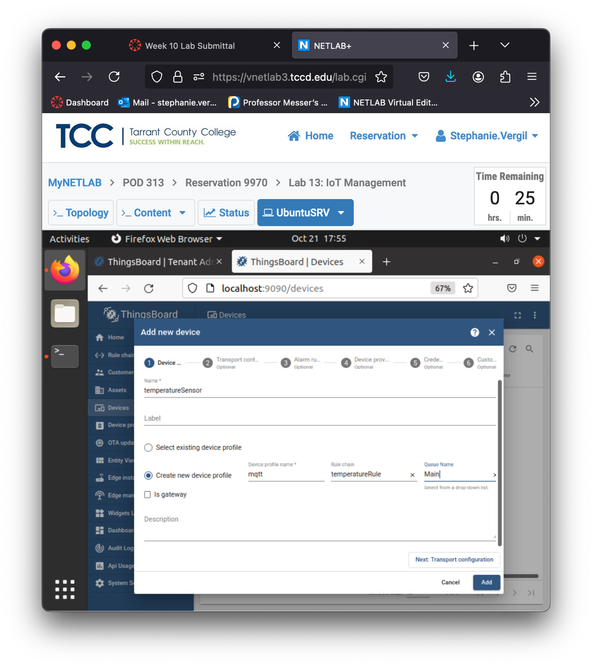

1. On the Transport Configuration page, click to change the Transport type to MQTT. Then, change the Telemetry topic filter to v1/devices/temperatureSensor/telemetry and change the Attributes topic filter to v1/devices/temperatureSensor/attributes

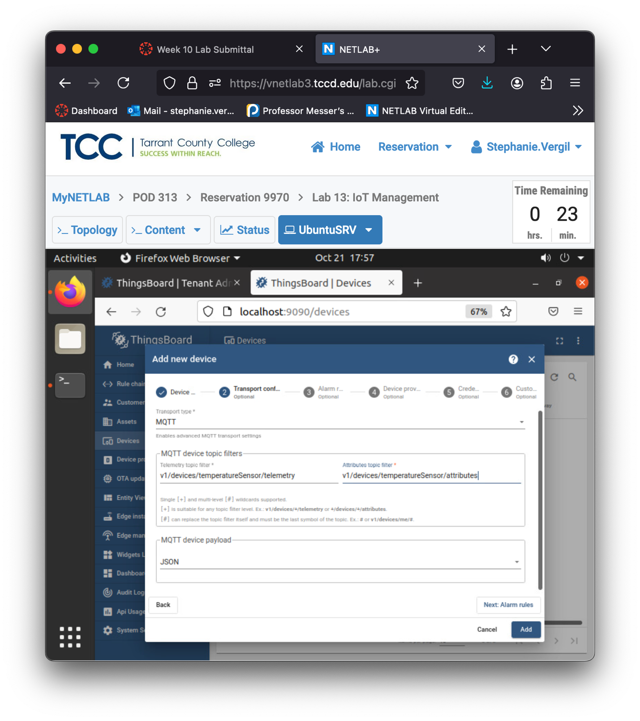

1. On the Alarm rules page, we will not add any rules. Click Next: Device provisioning to continue.
2. On the Device provisioning page, do not change anything, click Next: Credentials to continue.
3. On the Credentials page, we will not add credentials. Click Next: Customer to continue.
4. Click to select test_customer in the Customer to assign the device field. Click Add to add the device.

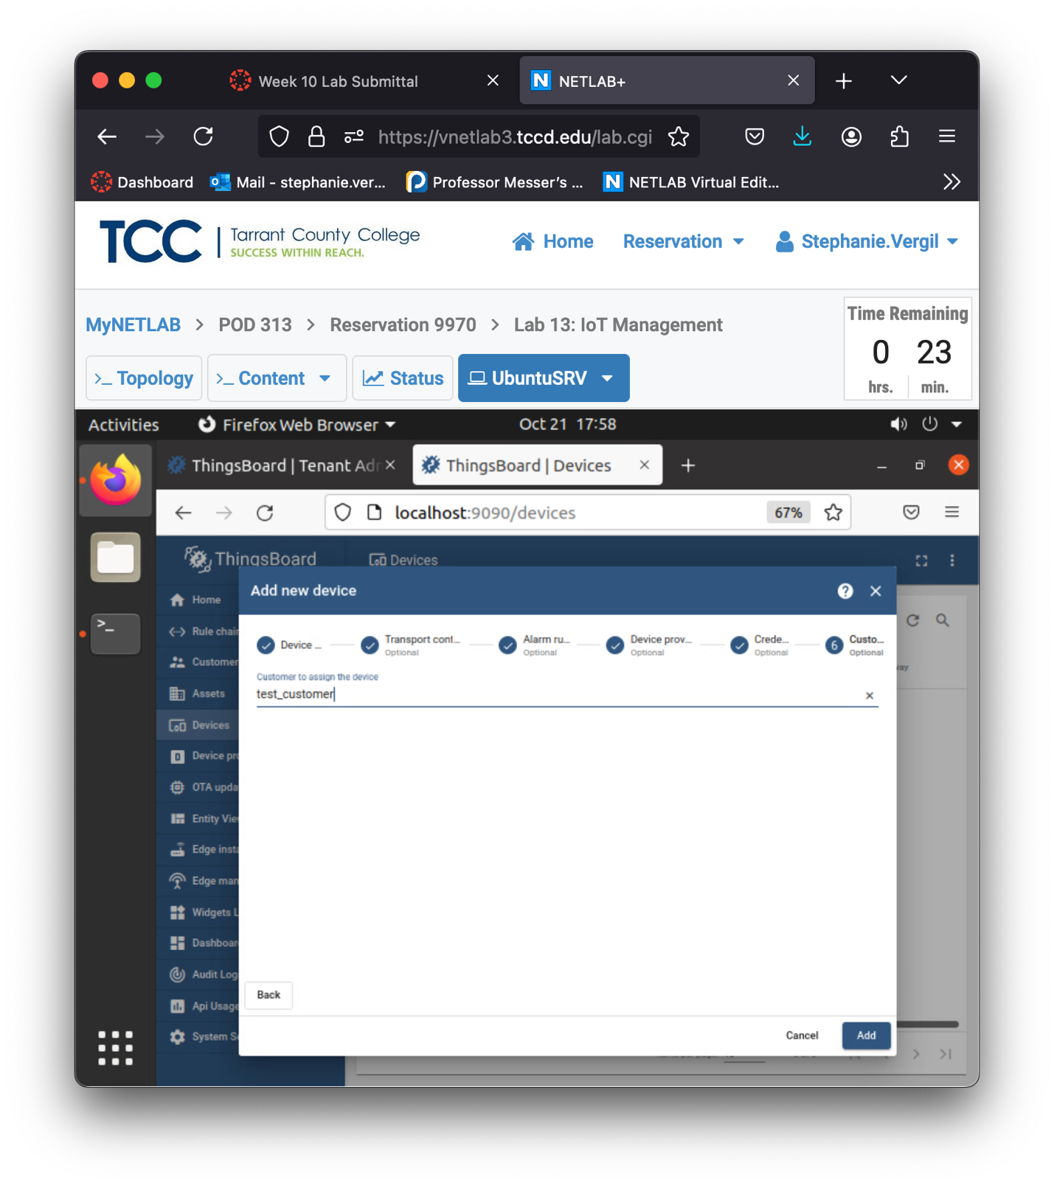

1. Leave the ThingsBoard window open and proceed to the next section.
2. Testing the Device
3. A quick way to test the device we created is to send an MQTT message to the ThingsBoard server from the terminal. First, we will get the access token from our temperatureSensor device. With the ThingsBoard still open, make sure you are still on the Devices page. Then, click on the temperatureSensor once.
4. A panel will slide open from the right side. Click on Copy access token.
5. A pop-up message will show quickly at the lower-right corner, indicating that the Device access token has been copied to clipboard. Click Close.

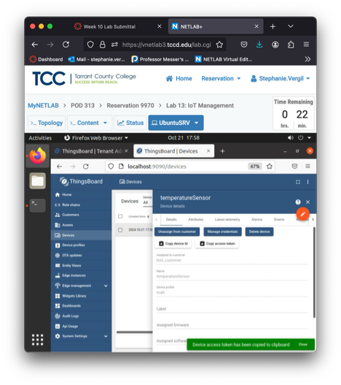

1. Once the token is copied, click Latest temeletry and we will observe the data from this tab. Right now, there is no telemetry at all.
2. Start a new terminal and enter the following command. Replace the $ACCESS_TOKEN with the token we just copied. Press Enter to send the message to the ThingsBoard server. sysadmin@ubuntusrv:~$ mosquitto_pub -d -q 1 -h "127.0.0.1" -t "v1/devices/temperatureSensor/telemetry" -u "$ACCESS_TOKEN" -m "{"temperature":69,”humidity”:56}"

Note: The $ACCESS_TOKEN must be replaced for the message to work. The

token in the example will be different from yours.

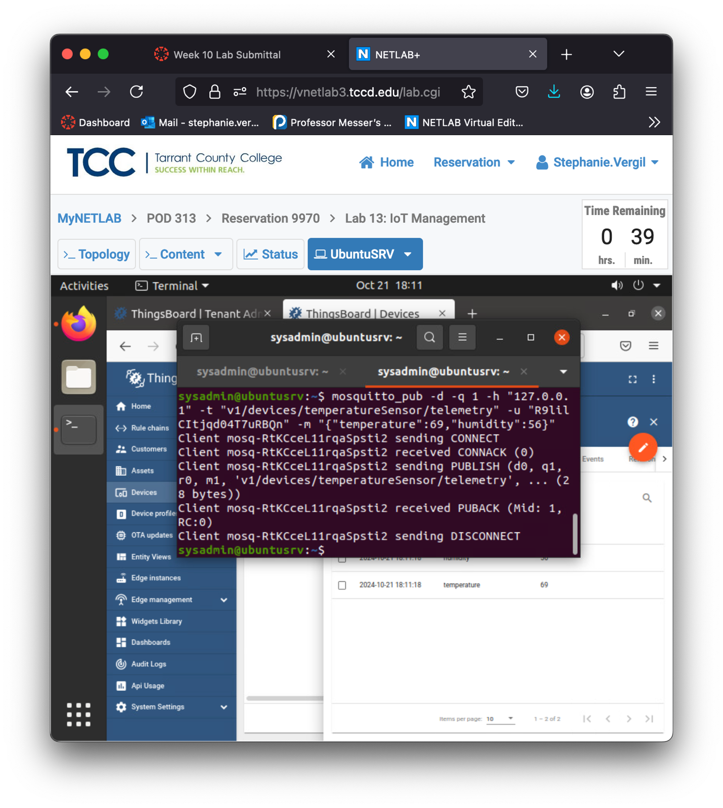

1. Immediately, you should see a telemetry show up in the ThingsBoard, under the Latest telemetry tab.

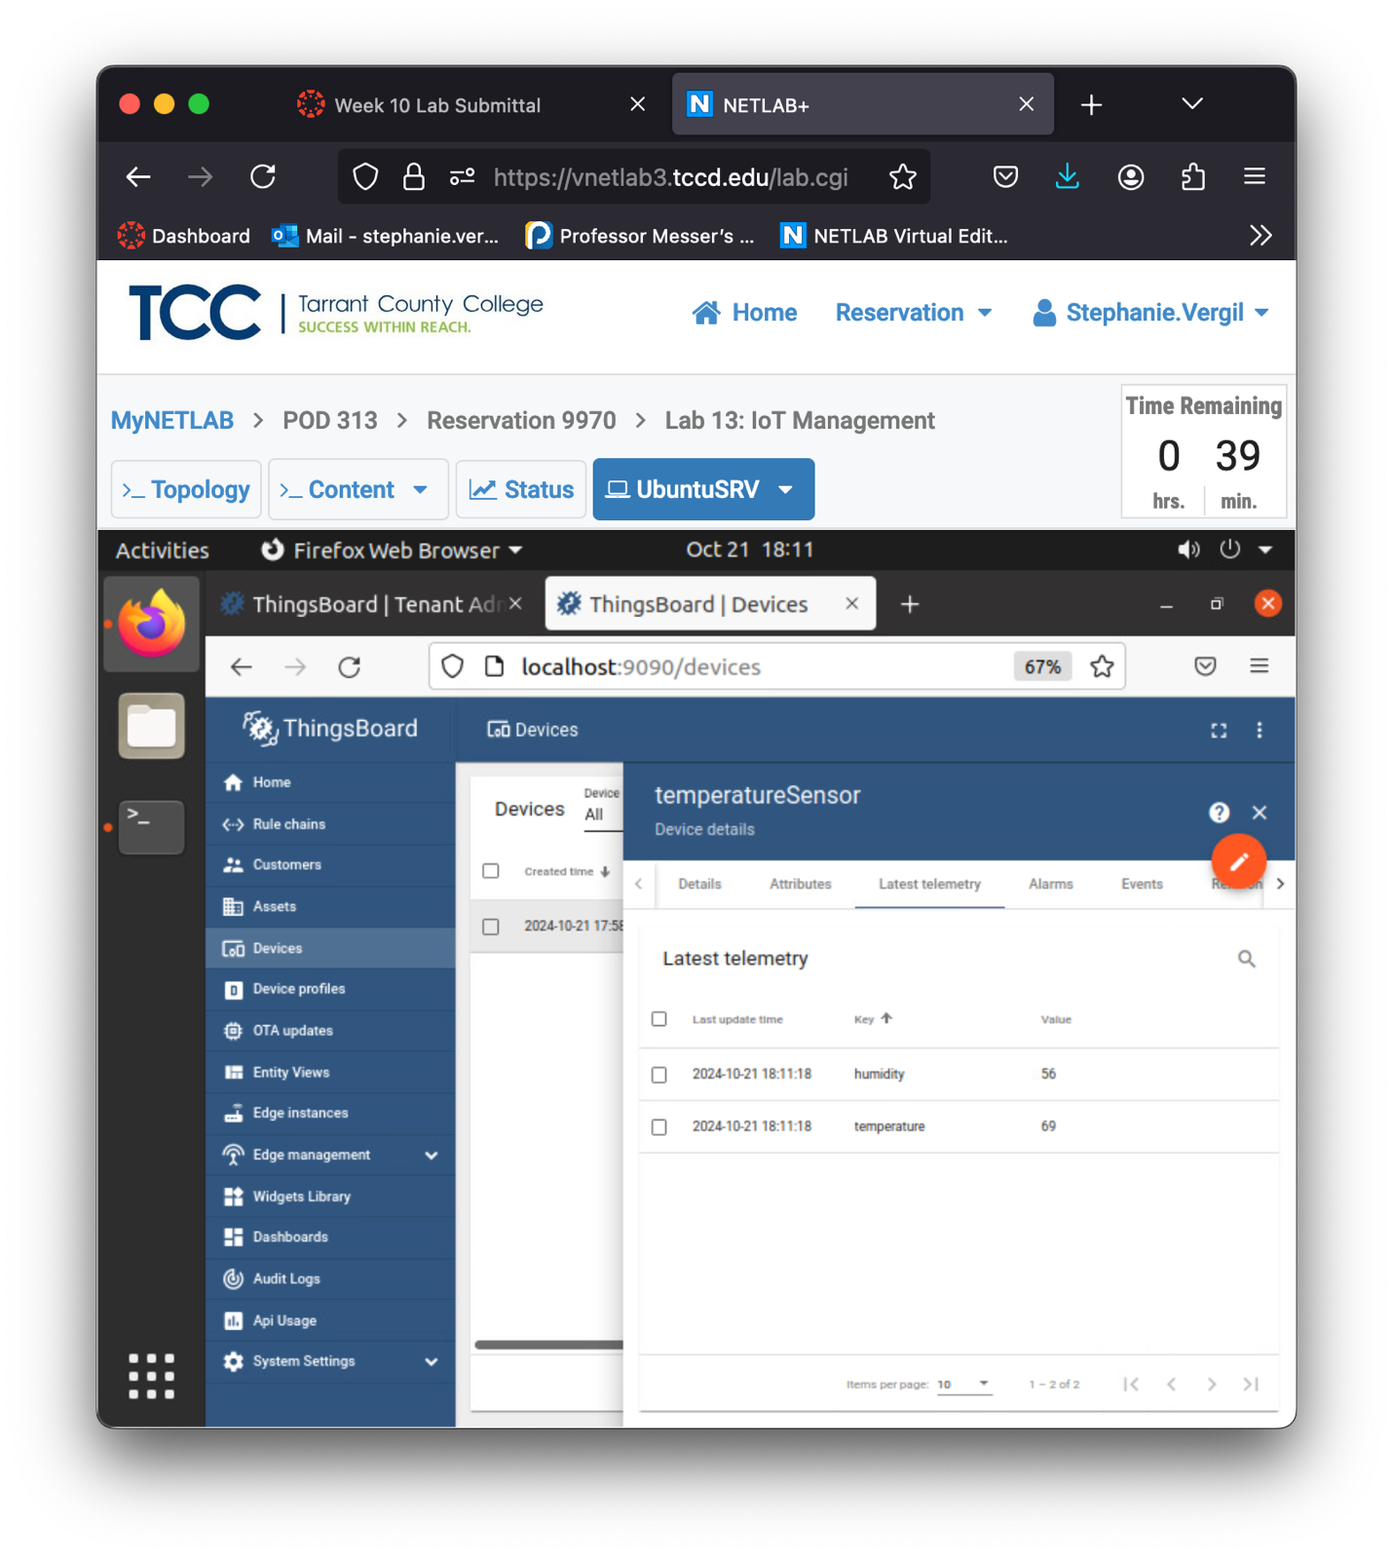

1. Alternatively, you could move the Terminal window to show the Latest telemetry in the background. Then, change the humidity to 50 and run the command again.

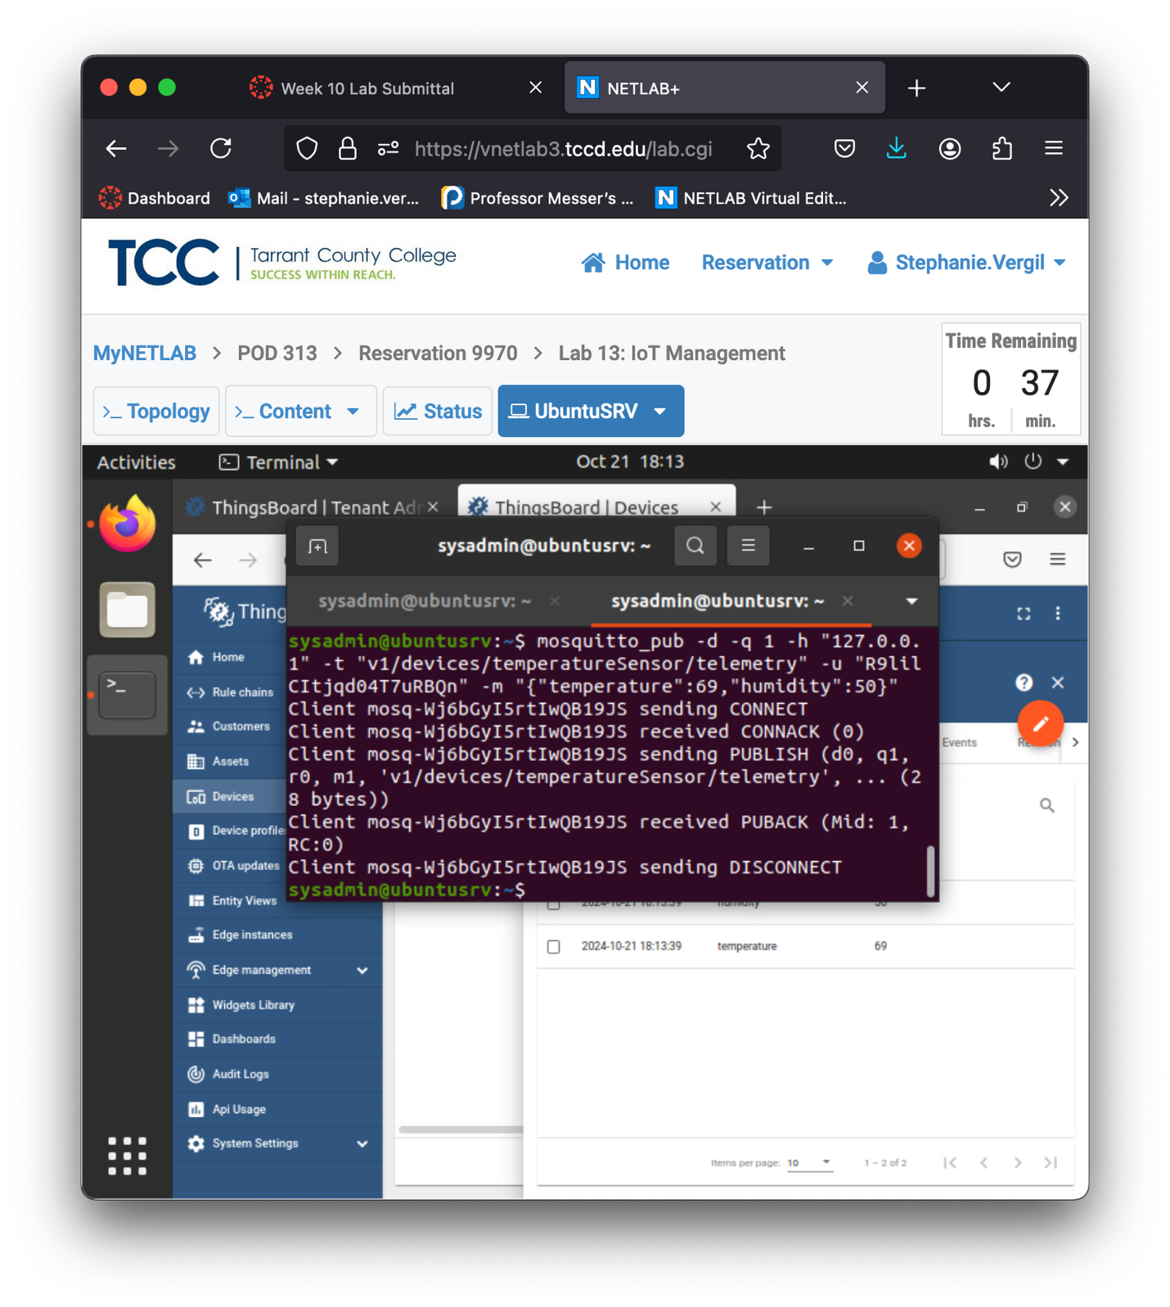

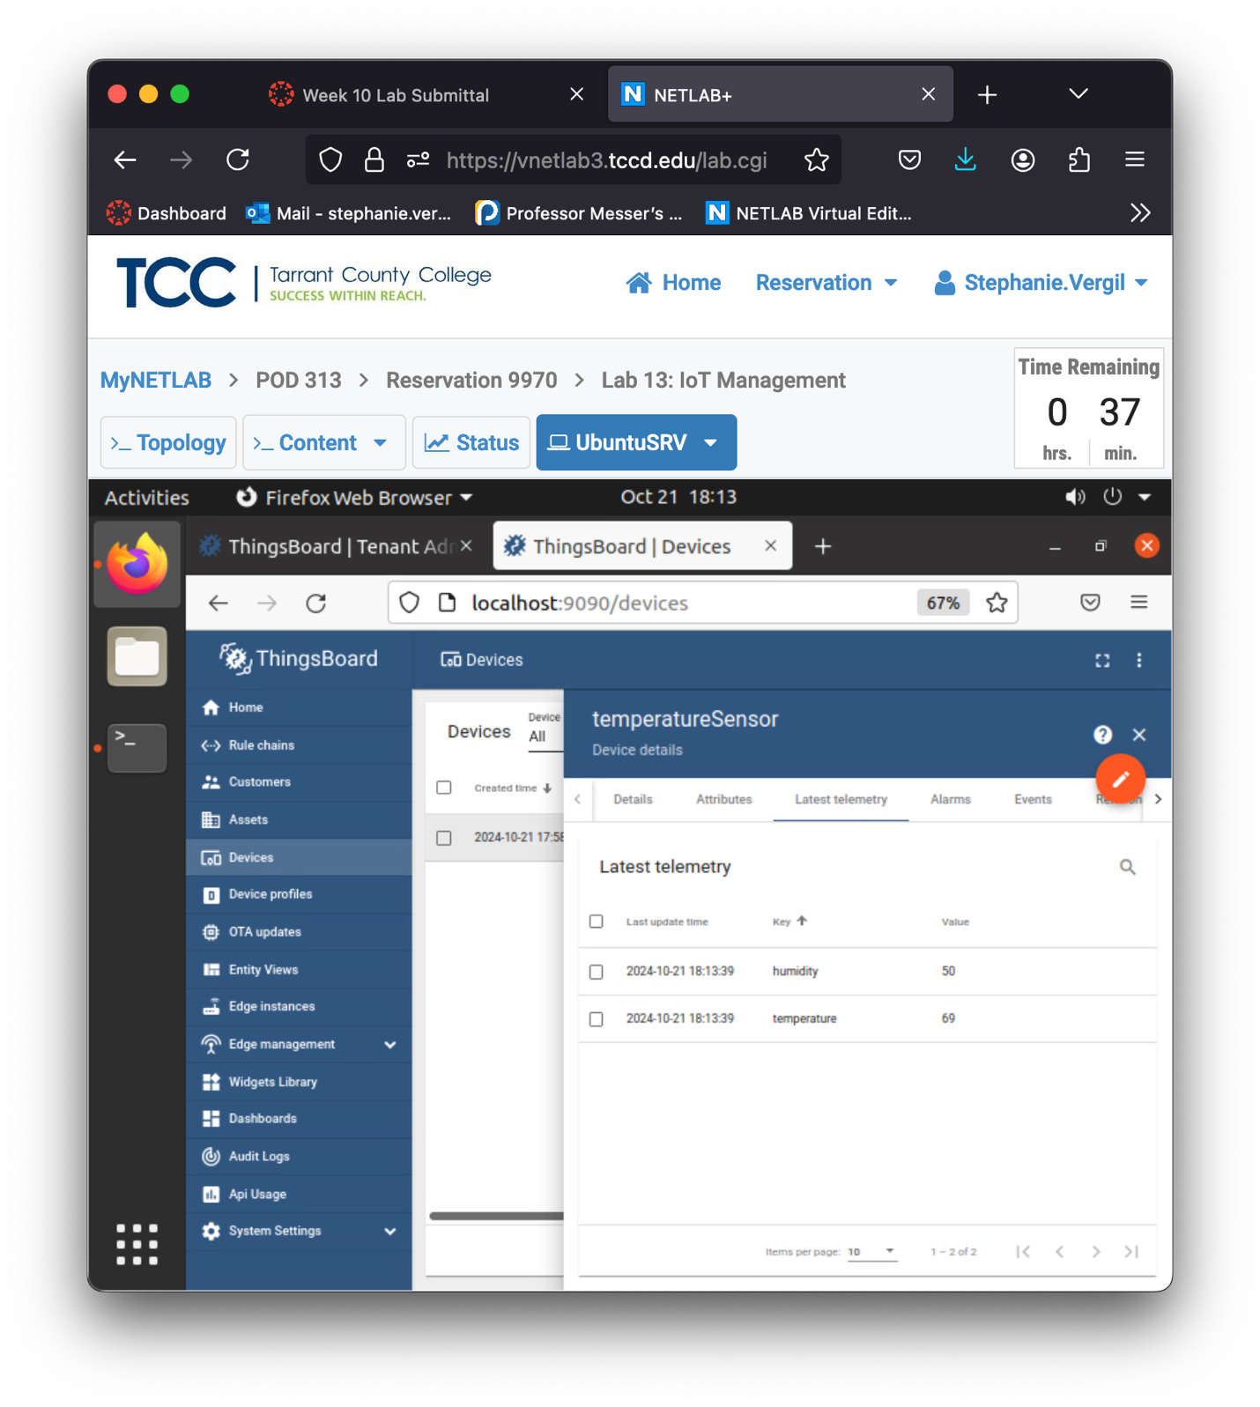

1. Now, we will set a higher temperature to create an alarm. Go back to the ThingsBoard and click on the Alarms tab. There is nothing right now.
2. Switch back to the Terminal window; we will send another MQTT message but with a temperature of 85. An alarm will show up with a Severity level of Critical. If the Alarm page does not refresh itself, click the Refresh button.

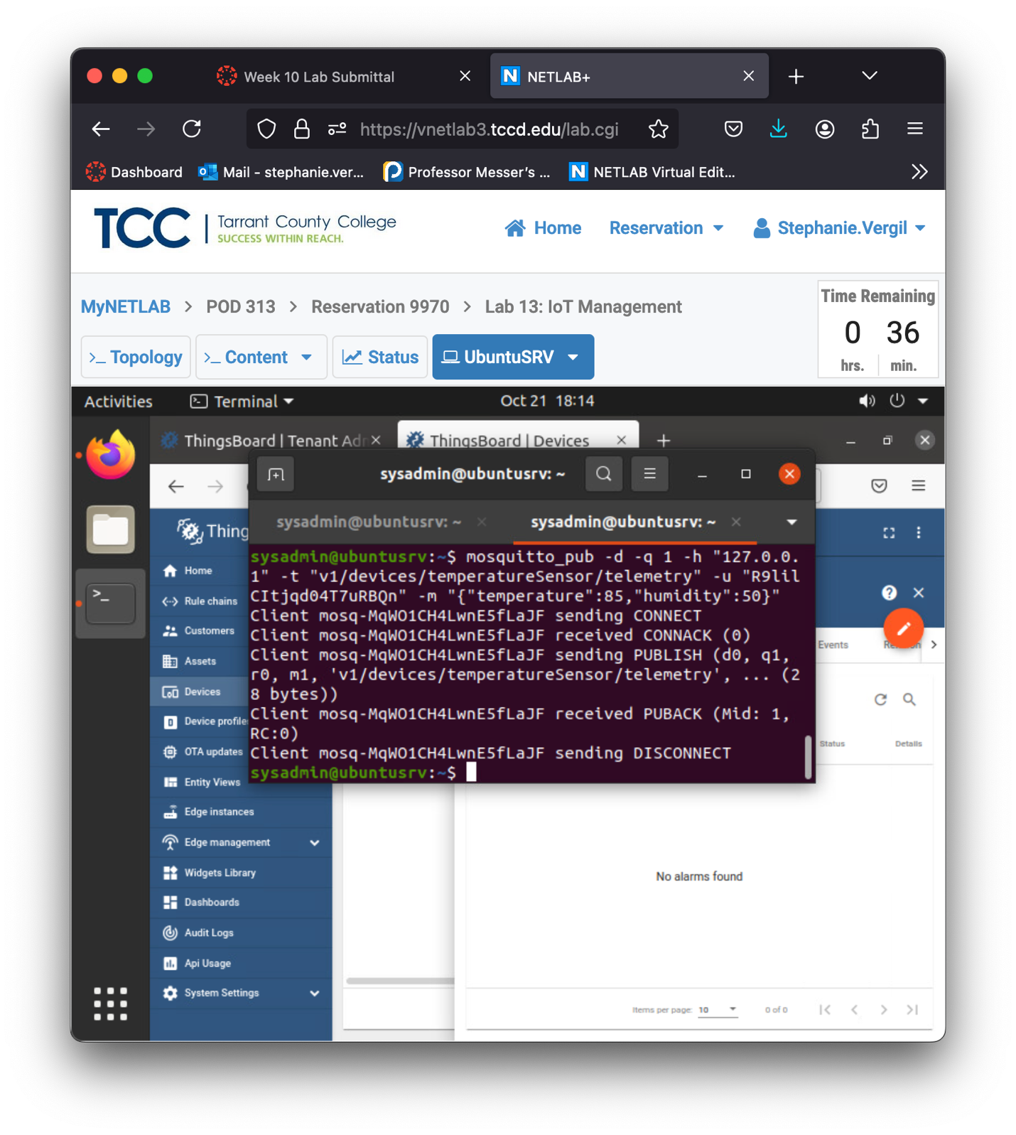

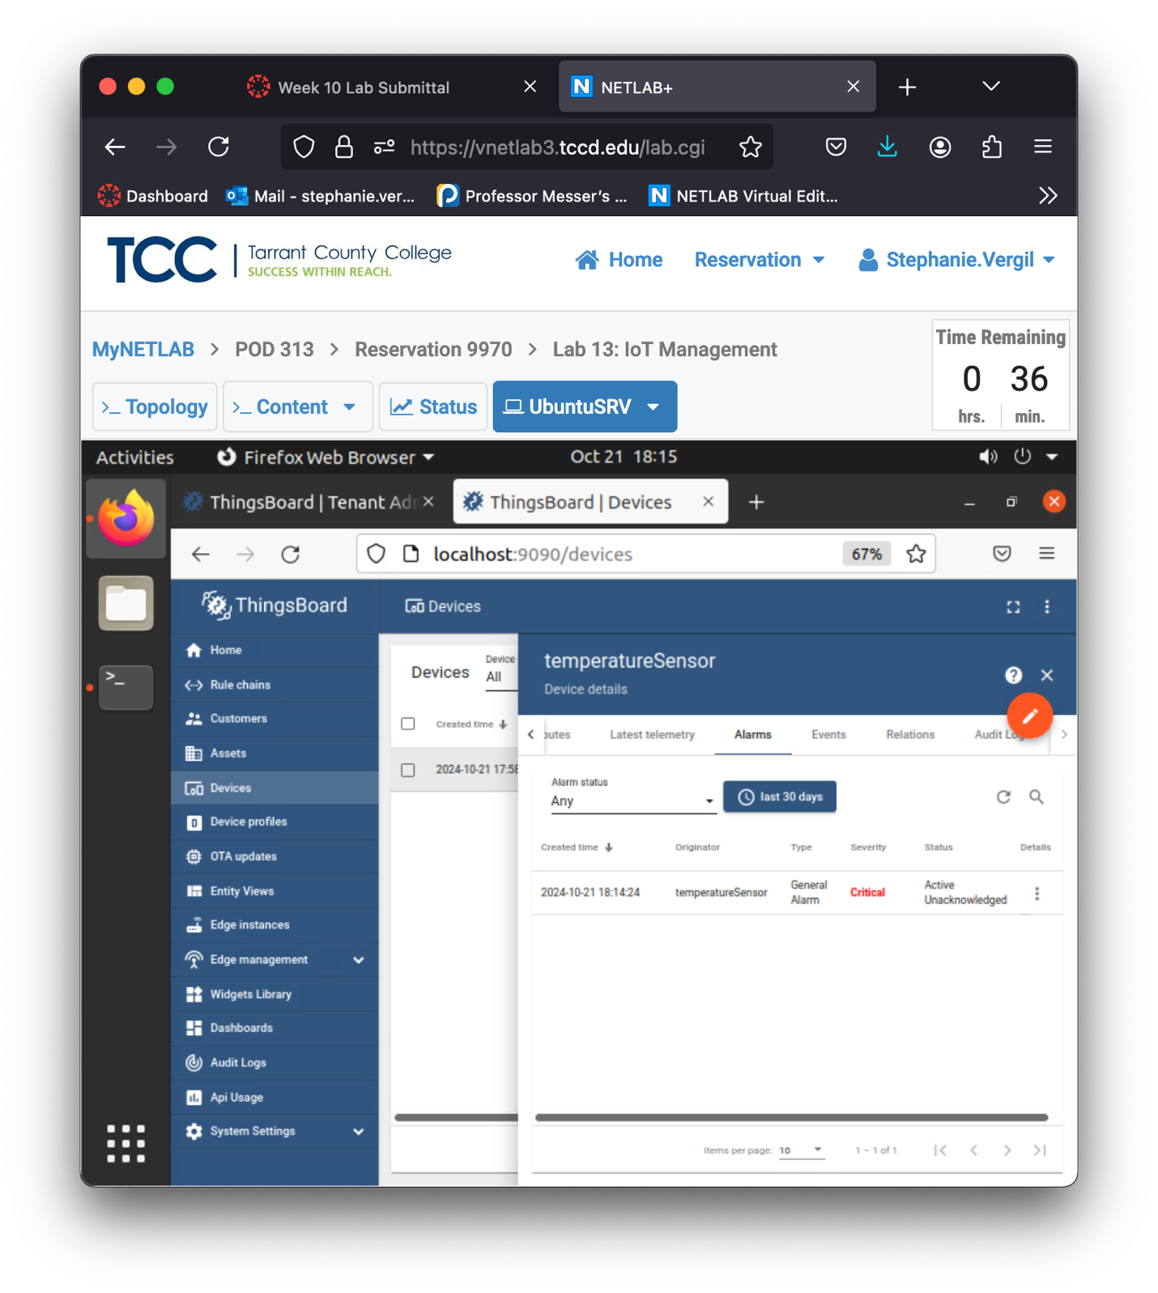

1. We can acknowledge the alarm and even clear the alarm once it has been dealt with. Click the Details button.
2. In the pop-up window, click Acknowledge, then click Clear. Once cleared, you can click the Close to exit the pop-up window

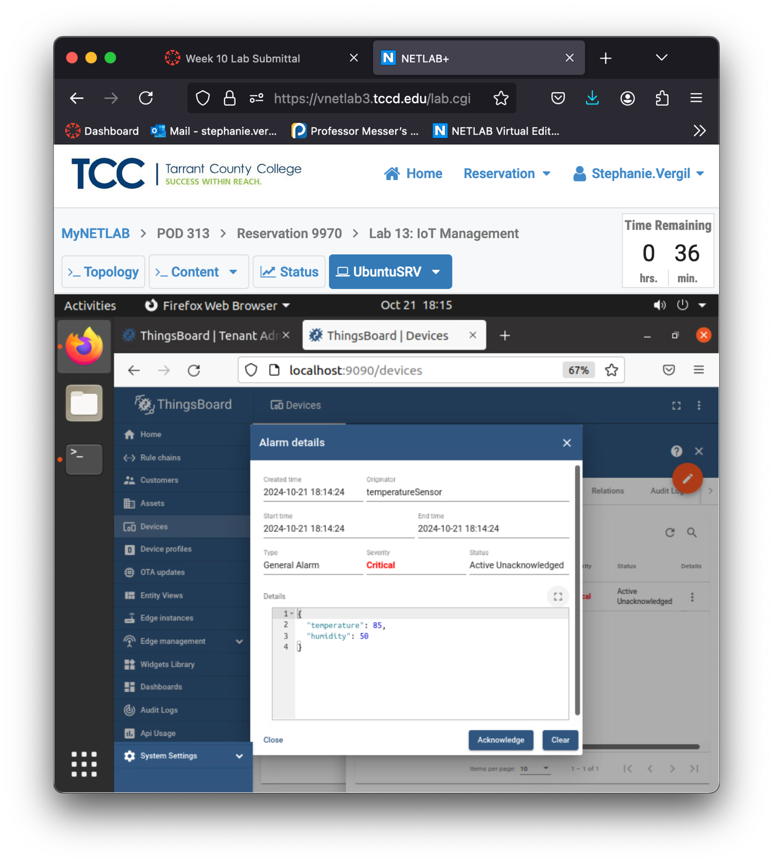

1. Now the Status should indicate Cleared Acknowledged.

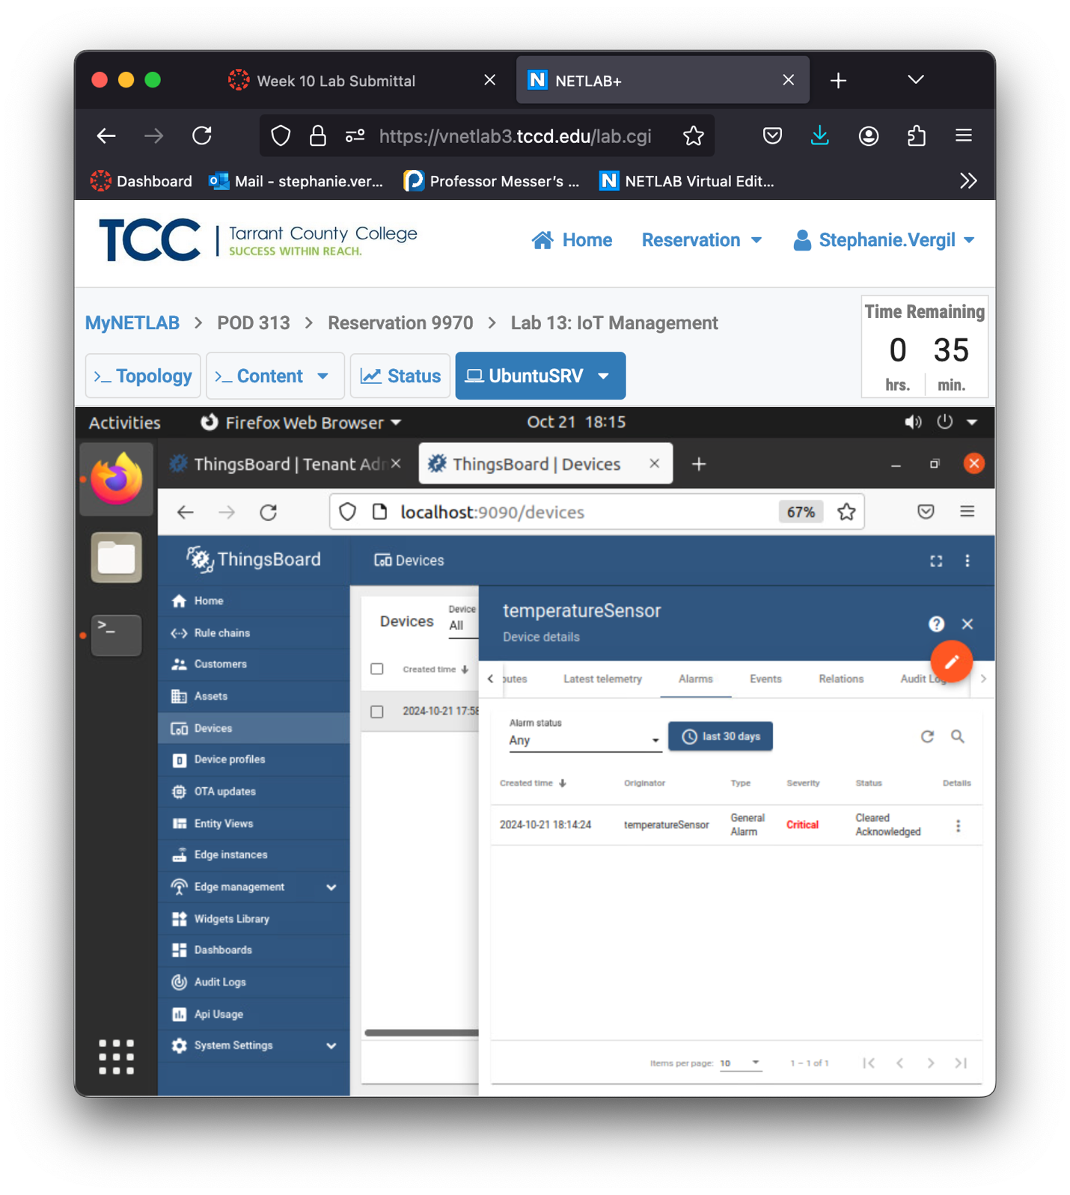

1. Lab completed